**Integrating Expense Tracking with AI-Driven Investment Recommendations**

Dr. Shanthi S 1, Praveen Giridhar Pawaskar 2, Abdul Aman Khan 3, Rehan Ashraf 4, and Mihir Suman P 5

*1Associate Professor, Presidency University, Bangalore*

*2 Assistant Professor, Presidency University, Bangalore*

*345Department of CSE, Presidency University, Bangalore*

***Abstract—* The Expense Tracker is a comprehensive financial management application developed using the MERN stack—MongoDB, Express.js, React, and Node.js—to simplify expense tracking, budgeting, and investment decision-making. The application features a secure backend powered by Node.js and Express.js, utilizing RESTful APIs for efficient data handling, while MongoDB ensures flexible and scalable data storage. The React-based front end provides a responsive and intuitive interface, enabling users to seamlessly input, categorize, and visualize their expenses. Core functionalities include user authentication for secure and personalized access, secure expense logging to maintain accurate financial records, category management and budget tracking for effective financial organization, and interactive charts offering real-time insights into spending patterns.**

**A key innovation of the application is the PennyDrop feature, which leverages user income and expense data to provide personalized investment suggestions. Using data-driven algorithms, PennyDrop empowers users to make informed financial decisions by aligning their income with tailored investment opportunities. This integration of expense tracking with actionable investment insights creates a holistic platform for financial management. The application is designed to be scalable, maintainable, and user-friendly, making it an ideal solution for individuals and businesses seeking an efficient tool for managing their finances and optimizing their investments.**

***Index Terms—* Budget Tracking, Category Management, Data-Driven Investment Insights, Expense Categorization, Expense Input, Expense Logging, Financial Management Application, Income-Based Investment Suggestions, Interactive Charts, MERN, PennyDrop Feature, Personalized Financial Solutions, Real-Time Financial Insights, RESTful APIs, Scalable Data Storage.**

**I. INTRODUCTION**

Managing personal finances has become an increasingly challenging task for individuals in today’s dynamic and intricate financial landscape. Outdated methods of expense tracking and budgeting often fail to provide the level of convenience, precision, and insights required to achieve financial stability. This gap highlights the need for modern, technology-driven solutions that can simplify financial management while empowering users with actionable insights.

The Expense Tracker project addresses this need by leveraging the MERN stack—MongoDB, Express.js, React, and Node.js—to deliver a streamlined and user-friendly platform. This application goes beyond basic expense tracking by offering features such as secure expense logging, category management, budget tracking, and real-time financial visualization through interactive charts. Additionally, the inclusion of the PennyDrop feature introduces a unique capability: providing users with personalized investment recommendations based on their income and spending patterns. This feature bridges the gap between financial tracking and proactive wealth-building strategies, encouraging users to make informed financial decisions.

By integrating simplicity, security, and advanced functionality, the Expense Tracker aims to redefine the way individuals engage with their finances. The project not only seeks to address the limitations of traditional financial management methods but also emphasizes the importance of financial literacy, equipping users with the knowledge and tools to take control of their financial future. This paper explores the development, features, and impact of the Expense Tracker, highlighting its potential to inspire confidence and foster long-term financial stability.

**II. LITERATURE SERVEY**

PennyTrack and PennyDrop represents an innovative integration of expense tracking and AI-driven investment recommendations, built on the MERN stack. The system's core functionality combines day-to-day expense management with intelligent investment planning through a CART (Classification and Regression Tree) model that analyzes income parameters (in LPA) to provide personalized investment suggestions. Drawing from established research in personal finance management and machine learning applications, PennyTrack addresses the growing need for automated financial planning tools that can both track current expenses and offer forward-looking investment guidance. This holistic approach not only helps users maintain better control over their daily expenses but also empowers them with AI-powered insights for making informed investment decisions based on their income level and spending patterns.

Han et al. [1] provide the fundamental concepts of data mining and machine learning techniques, particularly decision tree classification, which forms the theoretical basis for our investment recommendation model.

Pressman [2] outlines the software engineering principles crucial for developing robust financial applications. These principles guide our MERN stack implementation, ensuring scalability and maintainability of the PennyTrack application.

Geetha et al. [3] demonstrate the implementation of a comprehensive expenditure management system. Their work provides insights into-user interface design for financial applications, database schema optimization and transaction processing methods.

Garg et al. [4] present a detailed analysis of expense tracking systems, highlighting the importance regarding real-time transaction monitoring, category-based expense classification and budget management features

Their findings support our approach to expense categorization and budget tracking.

Sharma et al. [6] explore the application of machine learning algorithms in personal finance management, specifically in automated expense categorization, spending pattern analysis and predictive financial modelling.

Verma and Kumar [7] focus on integrating IoT technology with expense tracking systems, includes: automated expense logging through IoT sensors, real-time data synchronization across devices and cloud-based storage for expense data.

M Singh et al. [8] demonstrate the effectiveness of big data analytics in- real-time expense tracking, predictive budgeting and investment pattern analysis

Their work supports our approach to processing large-scale financial data for investment recommendations.

Gupta and Patel [9] discuss cloud-based solutions for expense management, addressing towards secure data storage, cross-device synchronization and real-time data processing. In findings inform our MERN stack implementation and cloud deployment strategy.

Kumar and Tiwari [10] focus on automation in personal finance management, covering: automated expense categorization, budget tracking algorithms and investment planning tool. Their research provides valuable insights for our AI-powered recommendation system.

**III. RESEARCH GAPS**

Effective financial management is essential for maintaining stability and achieving financial goals. Traditional methods of expense tracking, however, come with numerous limitations that hinder efficiency and accuracy. These outdated systems struggle to provide real-time insights, security, and convenience. Below are the key drawbacks of existing expense tracking methods:

Manual record keeping and paper-based systems are time-consuming, prone to human error, and susceptible to physical damage or loss, making consistency and organization difficult over time.

Basic spreadsheets require manual data entry and formula management, lack real-time updates and notifications, and offer limited data visualization, hindering effective financial tracking.

The absence of categorization complicates identifying spending patterns and budgeting, while the lack of real-time tracking delays awareness of overspending and impacts timely financial decisions.

Limited analytical capabilities prevent automated insights and spending trend analysis, making it difficult to generate comprehensive financial reports and manage long-term financial history.

The lack of multi-device synchronization and security measures leads to inconsistent data access, vulnerability to data breaches, and challenges in sharing financial information with others for collaborative budgeting.

**IV. SYSTEM ARCHITECTURE**

The architecture of the Expense Tracker application is designed to integrate intuitive expense tracking with advanced investment recommendation capabilities. Built using the MERN stack, the system ensures seamless functionality, scalability, and maintainability. The application consists of two main components: PennyTrack for expense tracking and budgeting, and PennyDrop for personalized investment suggestions. Both components are interconnected through secure data handling processes and user-friendly interfaces, ensuring a comprehensive financial management experience.

**PennyTrack Architecture**

The PennyTrack module facilitates efficient expense management by providing a dashboard for income, expenses, budgeting, reminders, and transactions. The user inputs data into the system, which is stored securely in a MongoDB database. This data is then categorized and analyzed to generate visual insights through interactive charts. The architecture emphasizes ease of use, enabling users to monitor their financial activities in real time.

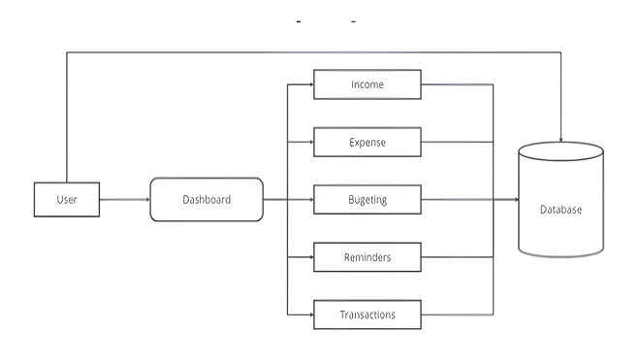

Fig 1. PennyTrack Architecture

**PennyDrop Architecture**

The PennyDrop module leverages machine learning to provide tailored investment suggestions based on user income and spending patterns. The system comprises the following stages:

Training Process: A dataset of investment options is preprocessed using label encoders and a decision tree model to categorize investment types and risk levels. The trained model is stored and used for inference.

Request Processing: A Flask application serves as the backend, processing user requests and validating income details. Features are prepared, predictions are made using the trained model, and results are decoded.

Client Interaction: The application interacts with users through JSON responses, delivering investment suggestions in a structured format via API requests.

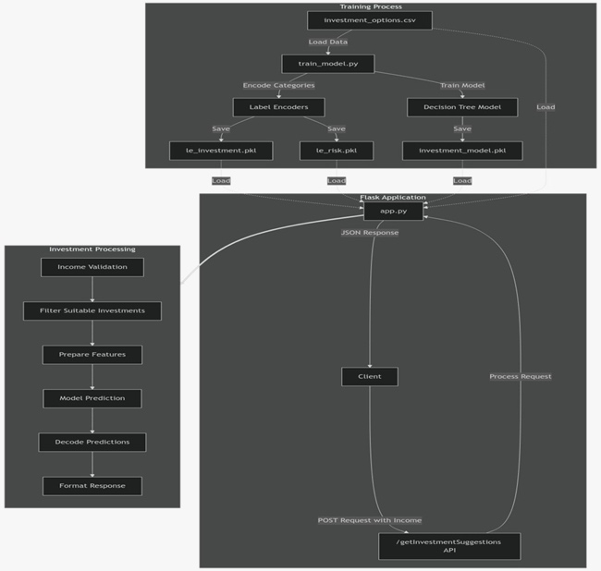

Fig 2. PennyDrop Architecture

**V. METHODOLOGY**

To address the limitations of traditional expense tracking methods, a comprehensive and technology-driven solution is essential. The proposed system integrates advanced financial management tools with AI-powered investment recommendations to offer seamless, secure, and insightful financial tracking. This approach ensures real-time data access, automated insights, and personalized financial guidance for effective decision-making. The core components of this methodology include:

**Multi-Device Synchronization:** Seamless task transition between devices ensures users can manage finances effortlessly across platforms. An intuitive UI/UX with responsive design and customizable dashboards enhances user engagement, while accessibility features and interactive elements simplify data management.

**Income Tracking:** Enables logging of multiple income sources, supports recurring entries, and provides visual insights into income trends. It calculates net income after expenses and offers suggestions for income allocation and savings.

**Weekly and Monthly Analysis:** Generates visual reports, including pie charts and trend analysis, allowing users to compare actual spending against budgeted amounts. It highlights top spending categories and supports flexible reporting periods for detailed financial insights.

**Expense Categorization and Budgeting:** Automatically categorizes expenses into predefined or customizable categories. Users can set budgets for each category, receive alerts for overspending, and get suggestions for staying within budget.

**Comprehensive Financial Planning Tools:** Offers retirement planning tools, tax optimization strategies, and debt management tools with payoff visualizations. This empowers users to develop long-term financial strategies.

**Investment Tracking and Analysis:** Monitors investment portfolios across various asset classes, provides performance metrics, and delivers risk assessments with diversification strategies tailored to individual goals. It also offers educational insights for informed investment decisions.

**App Authentication:** Implements robust security measures using JWT and OAuth2 authentication protocols. Supports two-factor authentication, encrypts stored financial data, and provides secure cloud backup options to prevent data loss.

**E-Wallet for Future Transactions:** Analysis of spending patterns to suggest optimal fund allocations, allowing easy fund transfers between the e-wallet and bank accounts, enhancing financial flexibility and planning.

**Algorithms:**

1. **PennyDrop**

PennyDrop is an investment recommendation system powered by a Decision Tree Classifier specifically (CART-Classification and Regression Tree) designed to provide personalized suggestions based on user financial data and risk tolerance. The model utilizes the Gini Index to evaluate the quality of data splits, ensuring precise and meaningful predictions. The formula for the Gini Index is:

$$Gini\left(S\right)=1- \sum_{i=1}^{k}{p_{i}^{2}}$$

Where:

* $p_{i}$ is the proportion of class $i$ in subset $S$

Key features include suitability for income ranges, risk levels, and maximum potential loss. During training, the model minimizes impurity through iterative splits, leading to tailored investment recommendations for users based on their financial profiles.

1. **Budget Tracking**

The Budget Tracker is a React-based tool that aids in monitoring and managing budgets effectively. It calculates spending metrics and tracks progress using the following formula:

$$Progress\left(\%\right)=\left(\frac{Spent Amount}{Threshold Amount}\right) ×100$$

Where:

* Spent Amount is calculated as:
$$Spent Amount=\sum_{t ϵ T_{c}}{t. amount}$$

* $T_{c}$: Transactions in category c
* $t$, amount: Transaction amount
* Threshold Amount is the maximum permissible spending before triggering a warning.

The Budget Tracker dynamically calculates spending progress for each category and highlights overspending risks through visual indicators, fostering financial discipline and better decision-making.

1. **Reminders**

To improve user engagement and adherence to financial goals, the system includes a notification feature that provides timely reminders for key financial tasks. These reminders ensure users stay on track with their budgets and investment objectives, optimizing financial management.

**D. Data-Driven Financial Optimization**

Both the PennyDrop and Budget Tracker components leverage data-driven algorithms to deliver a cohesive financial management solution. While PennyDrop provides actionable investment suggestions, the Budget Tracker ensures real-time monitoring of financial activities. Together, they create a robust system for personalized financial planning and optimization.

**VI. RESULTS**

The implementation of the Expense Tracker application effectively addresses the challenges of traditional expense management. The Android-based solution simplifies tracking and enhances financial awareness by replacing manual and error-prone methods. Automated daily and monthly budget adjustments help maintain financial stability, while real-time tracking and analytics support informed decision-making. Users reported increased savings through dynamic allowance recalculations and gained financial literacy through predictive tools and visual reports. Organizations also benefited from improved budgeting and cost management, highlighting the app's potential to improve personal and organizational financial control.

1. **Survey Insights:**

Need for Expense Tracking: 8 out of 10 students expressed the need for a tracker to manage their monthly allowances and control small expenses like food and travel.

Preferred Features: Users favoured categorized budgets (e.g., food, rent), daily expense tracking with reminders, and visual spending reports (graphs/charts).

Usage Frequency: 6 students preferred daily usage with automation, while others preferred weekly usage.

1. **Pain Points:**

5 students found manual tracking (Excel/notebooks) tedious.

3 students disliked complex apps and ads in free versions.

2 students were concerned about privacy and app permissions.

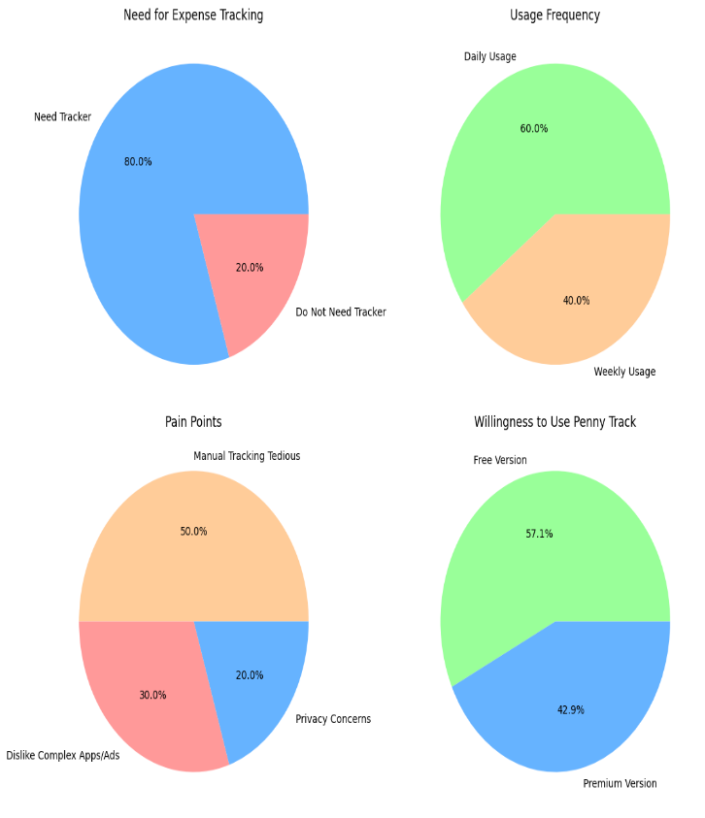

Fig.3 Survey Insights

**VII. CONCLUSION**

The expense tracker application provides users with a comprehensive set of tools to efficiently manage their finances. Starting from the intuitive landing page, users are seamlessly guided through the sign-up and login process to ensure secure access. Once authenticated, they are directed to a dynamic dashboard that enables them to track income, record expenses, set budgets, and review transaction histories, all visualized through intuitive insights. The income module allows users to categorize various income sources, while the expense module helps track and categorize expenditures, offering valuable insights into spending habits. The budgeting module facilitates personalized budget creation across different categories, promoting effective financial planning.

A standout feature of the application is the AI-powered PennyDrop investment recommendation system. This system uses machine learning algorithms, including a Decision Tree Classifier, to provide tailored investment suggestions based on users’ financial data and risk tolerance. By analyzing income, expenditure patterns, and risk levels, PennyDrop empowers users to make informed investment decisions, aligning their financial goals with suitable opportunities.

Additionally, the reminder module sends timely notifications to users, helping them stay organized and on track with their financial objectives. With these integrated features, the expense tracker not only enables users to optimize their spending but also guides them toward wealth creation, fostering financial awareness, stability, and long-term success.

**VIII. REFERENCES**

[1] J. Han, M. Kamber, and J. Pei, Data Mining: Concepts and Techniques (3rd Edition), Morgan Kaufmann Publishers, 2012, ISBN: 978-0-12-381479-1.

[2] R. Pressman, Software Engineering: A Practitioner’s Approach (5th Edition), McGraw-Hill, 2001.

[3] Dr. V. Geetha, G. Nikhitha, H. Sri Lasya, and Dr. C.K. Gomathy, “Expenditure Management System,” IEEE, May 16, 2022.

[4] Aman Garg, Mukul Goel, Sagar Mittal, and Mr. Shekhar Singh, “Expense Tracker,” International Journal for Research in Applied Science & Engineering Technology (IJRASET), Vol. 9, Issue IV, April 2021, pp. 1067–1070.

[5] “Online Income and Expense Tracker,” International Research Journal of Engineering and Technology (IRJET), Vol. 6, Issue 3, 2019, e-ISSN: 2395-0056, p-ISSN: 2395-0072.

[6] A. Sharma et al., “Personal Finance Management Using Machine Learning,” 2020. This paper explores machine learning algorithms for categorizing expenses and providing insights into spending patterns.

[7] R. Verma and S. Kumar, “Design and Development of an Expense Tracker Using IoT,” 2021. The paper presents a solution combining IoT technology and expense tracking for automated logging and syncing.

[8] M. Singh et al., “Expense Tracking and Budgeting System Using Big Data,” 2019. This study uses big data analytics for real-time expense insights and predictive budgeting.

[9] H. Gupta and N. Patel, “Cloud-Based Expense Management for Personal Finance,” 2020. This paper discusses using cloud computing for storing and managing finance data seamlessly across devices.

[10] S. Kumar and R. Tiwari, “Development of an Automated Personal Finance Management Application,” 2022. Focuses on automation for expense categorization and efficient budget tracking.